Report Title

By

Your Name

Course Title

Teacher’s Name

STEP1 . Check the structure of the customer’s table. The order of the columns must be:

ID – UserID – GivenName – Middlename – Surneme – gender – Bonus -

Query all the customers’ data.

Sort your customers by their ‘givennames’

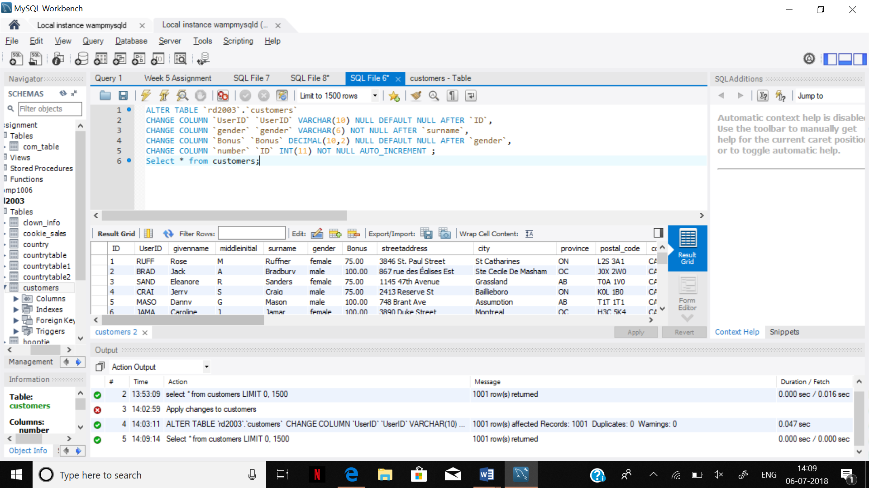

ALTER TABLE `rd2003`.`customers`

CHANGE COLUMN `UserID` `UserID` VARCHAR (10) NULL DEFAULT NULL AFTER `ID`,

CHANGE COLUMN `gender` `gender` VARCHAR (6) NOT NULL AFTER `surname`,

CHANGE COLUMN `Bonus` `Bonus` DECIMAL (10,2) NULL DEFAULT NULL AFTER `gender`,

CHANGE COLUMN `number` `ID` INT (11) NOT NULL AUTO_INCREMENT ;

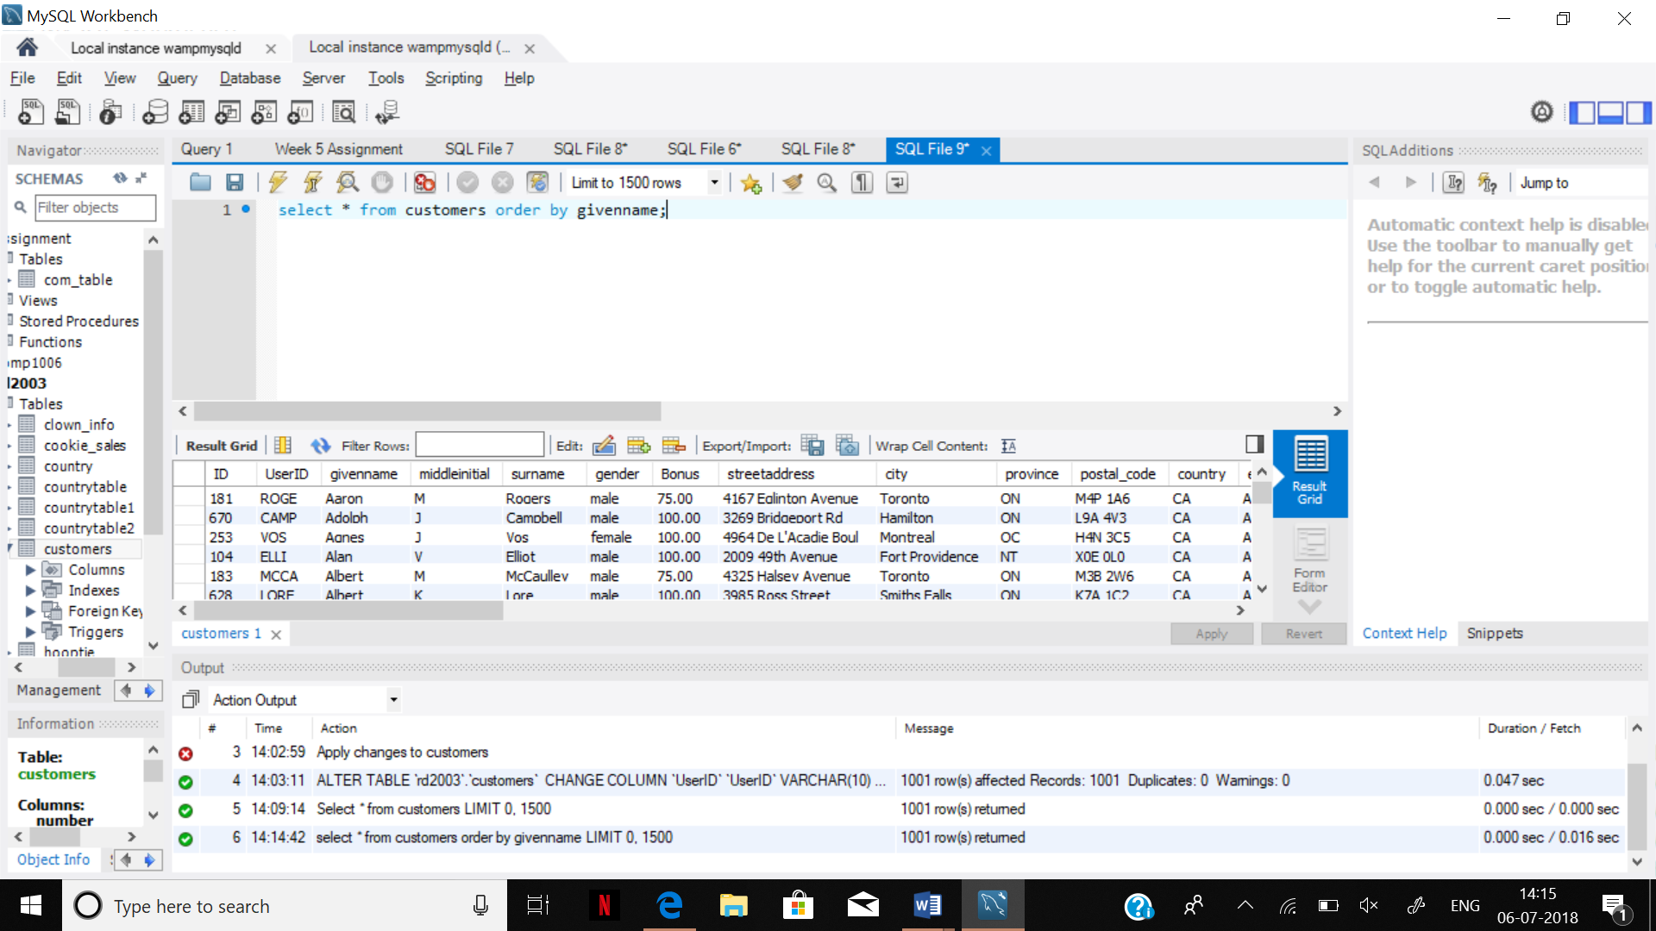

select * from customers order by givenname;

STEP 2.

1.How many customers are living in ‘Edmonton’?

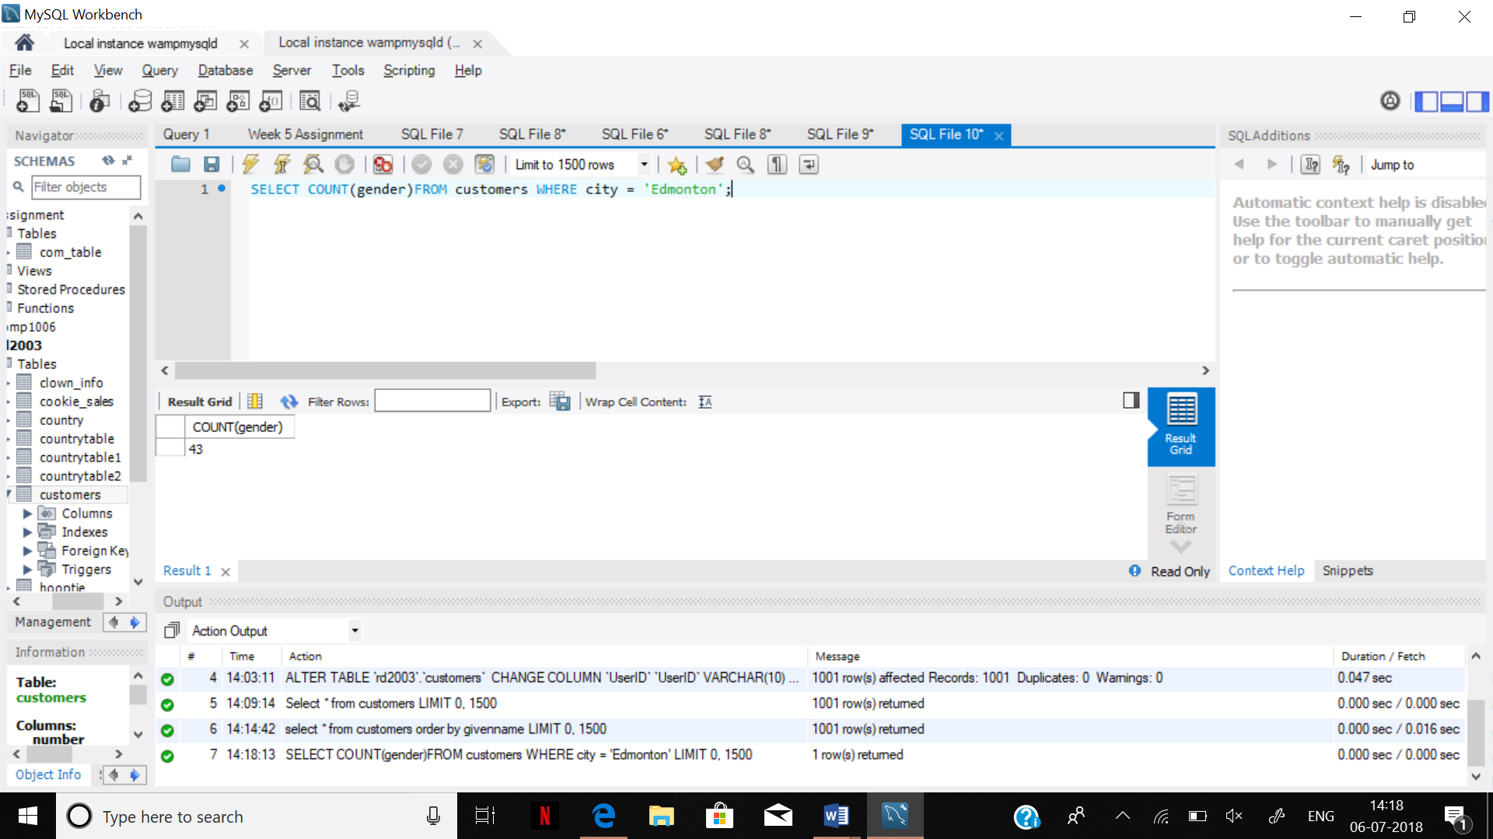

SELECT COUNT(gender)FROM customers WHERE city = 'Edmonton';

2. We want to add 75 CAD to the bonus of all the customers who are living in ‘Edmonton’. Write an update query and modify the table.

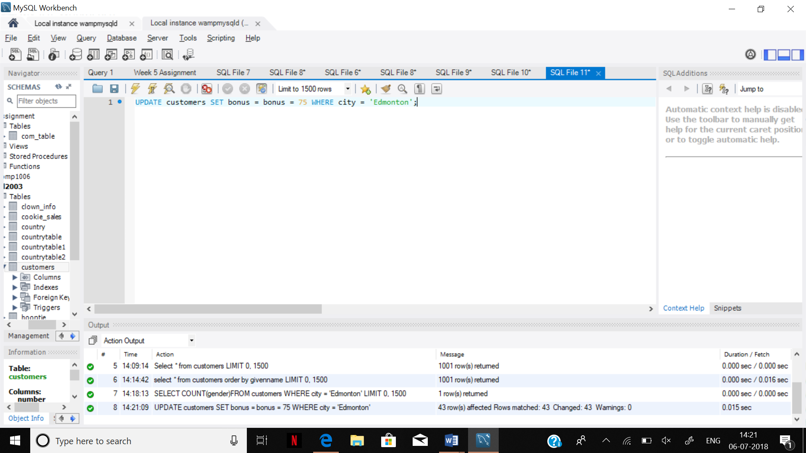

UPDATE customers SET bonus = bonus + 75 WHERE city = 'Edmonton';

3. With a simple SELECT command, show all the customers who live in ‘Edmonton’

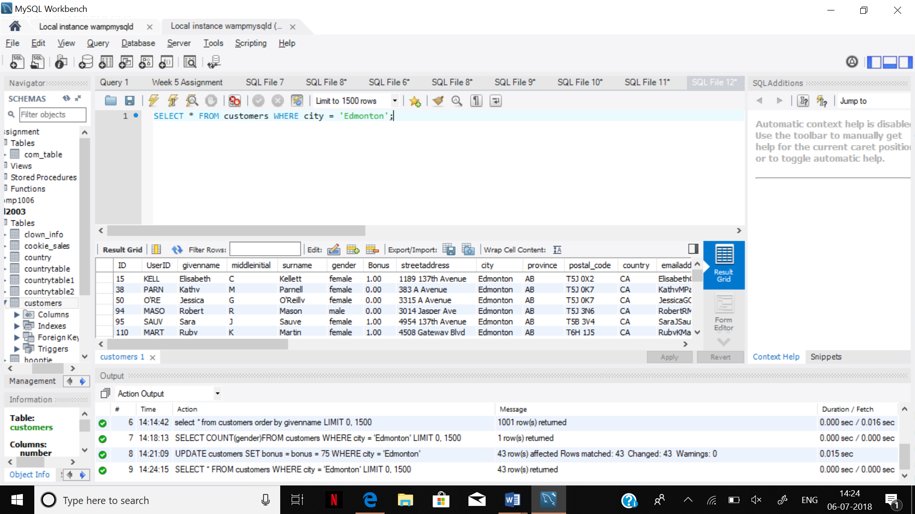

SELECT * FROM customers WHERE city = 'Edmonton';

Step 3.

1- We want to add 13 percent to the bonus column of all female customers.

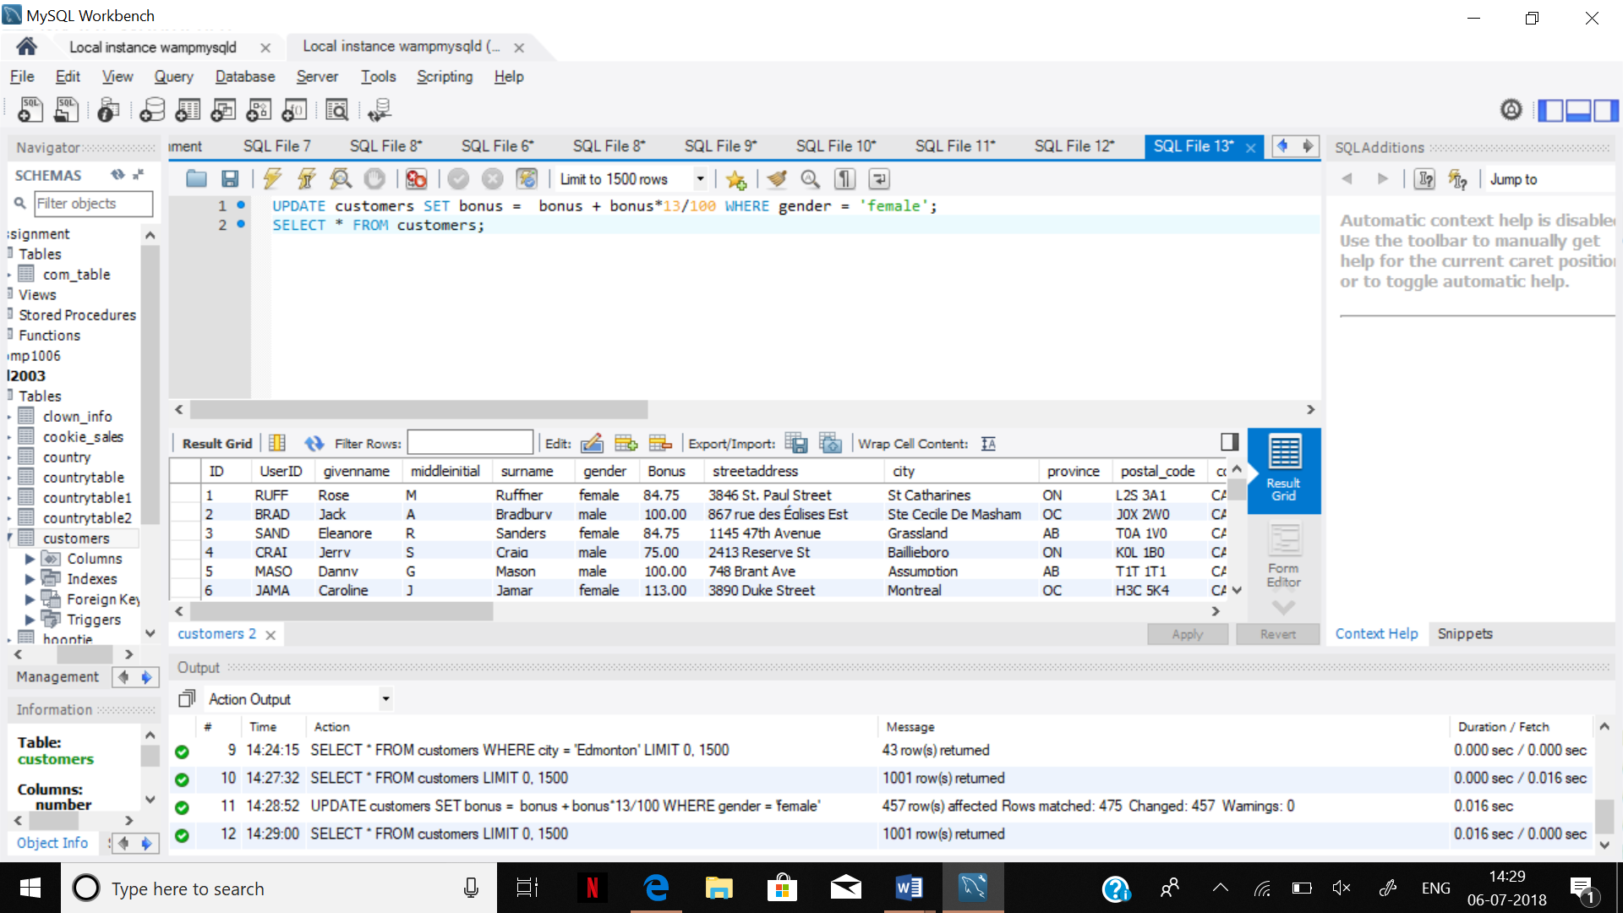

UPDATE customers SET bonus = bonus + bonus*13/100 WHERE gender = 'female';

2- Deduct 20 CAD from the customers who have (A, A-,A+, B+) blood types and add 35 CAD to the customers with (B-, O, O-) blood types.

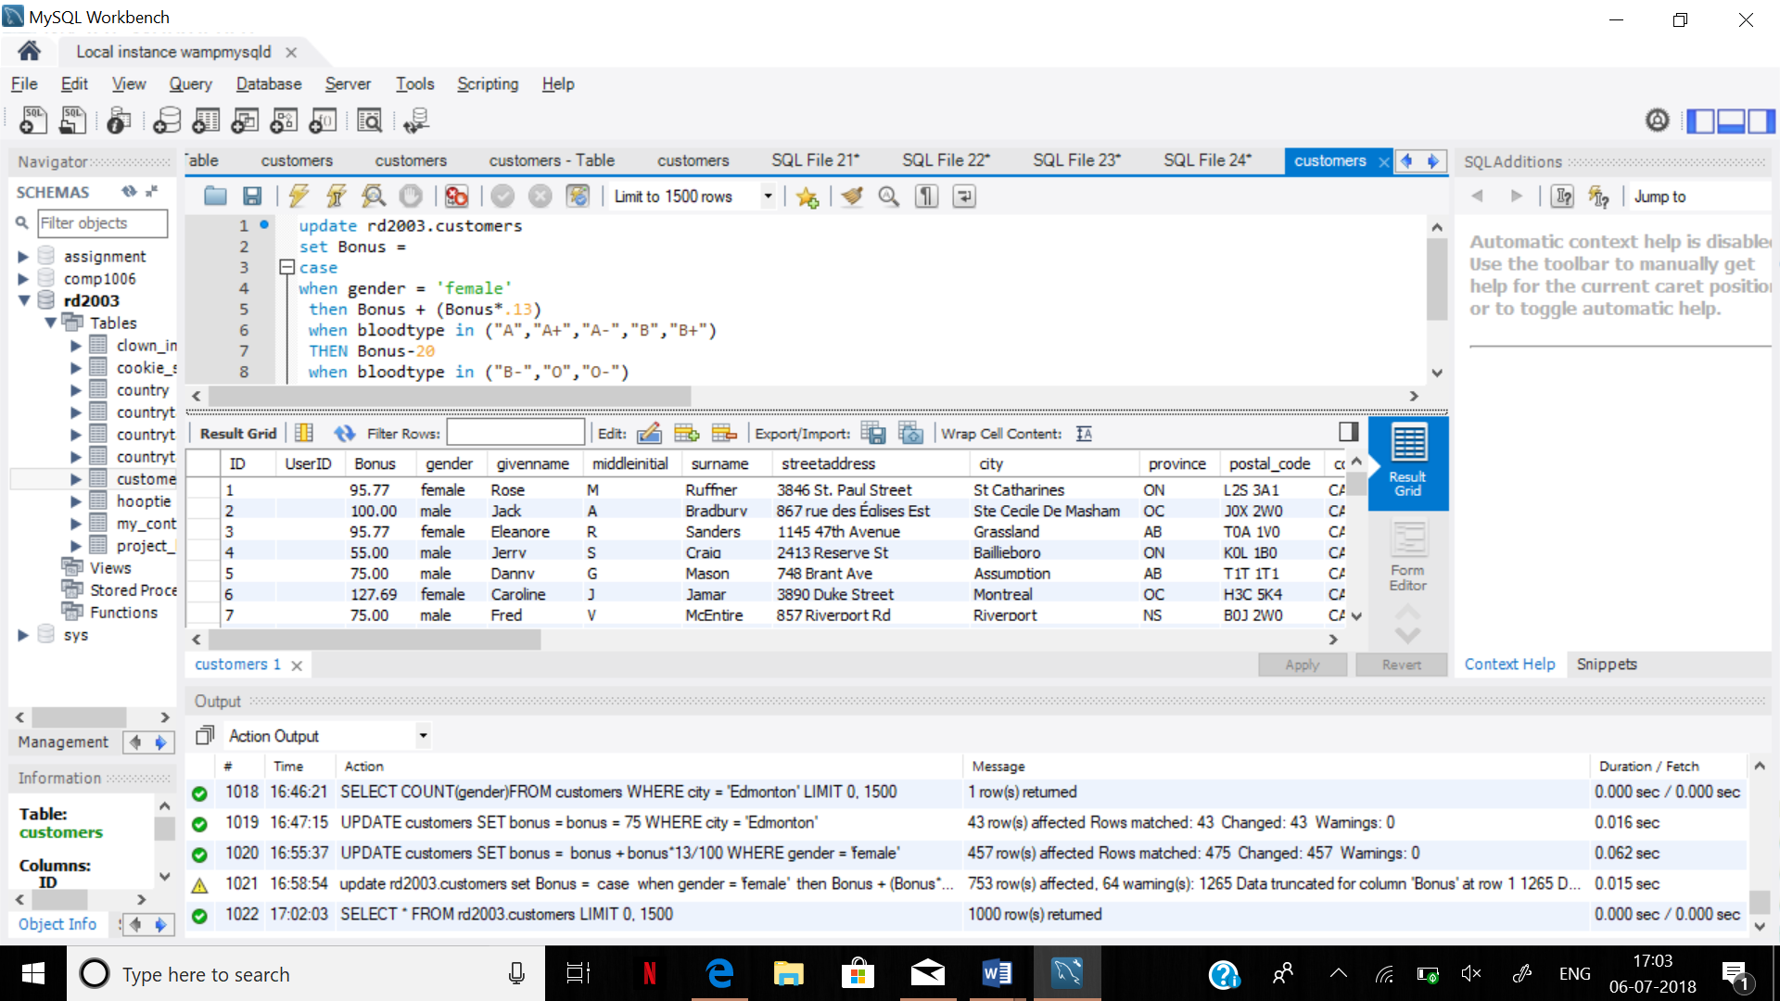

update rd2003.customers

set Bonus =

case

when gender = 'female'

then Bonus + (Bonus*.13)

when bloodtype in ("A","A+","A-","B","B+")

THEN Bonus-20

when bloodtype in ("B-","O","O-")

THEN Bonus+35

else Bonus

end;

STEP 4:

1.We need the five cities with highest paid bonus.

2.How much is the average amount of bonus that customers are receiving?

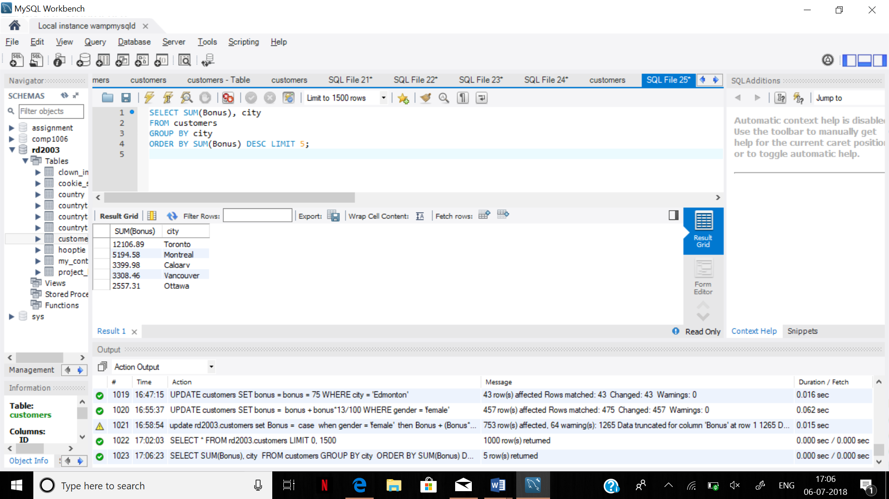

SELECT SUM(Bonus), city

FROM customers

GROUP BY city

ORDER BY SUM(Bonus) DESC LIMIT 5;

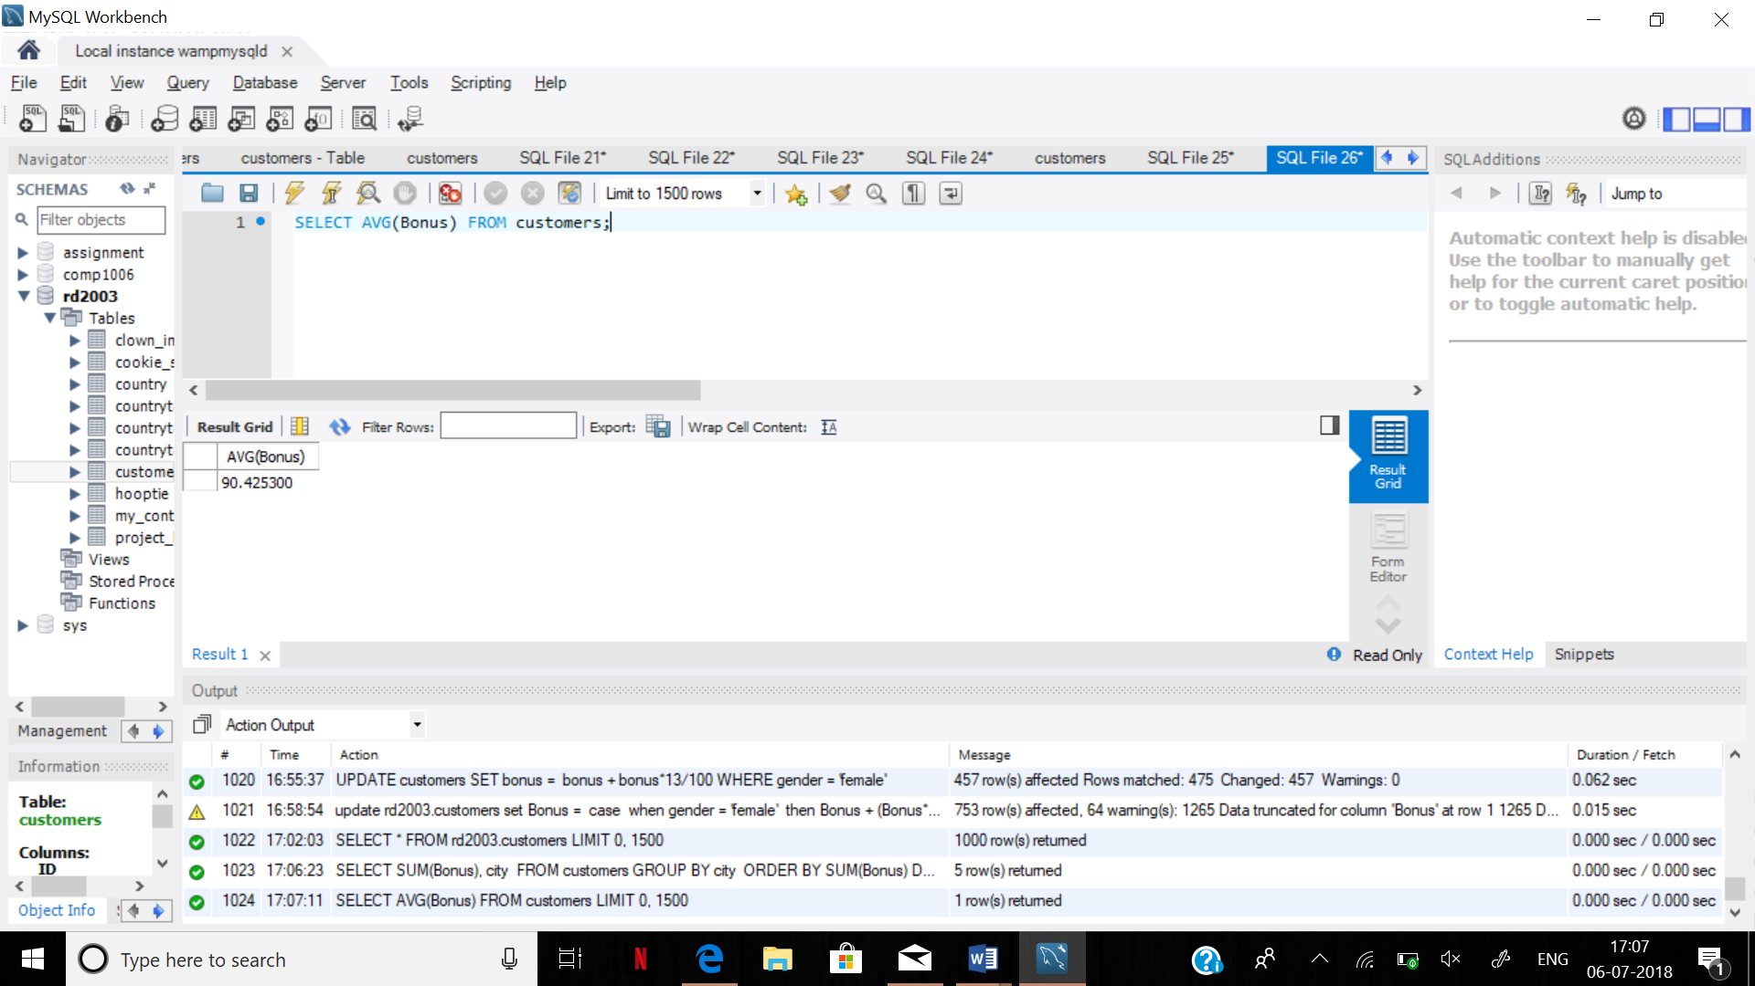

SELECT AVG(Bonus) FROM customers;

Step 5:

It will give all the information for the people to whom the lowest amount of bonus is being paid.

Step 6:

1. We need a list of provinces with the total bonus the customers sorted from highest to lowest amount of bonuses.
2. We need to know how many cities are in each province.
3. We want the average bonus in each province.
4. Can you combine all three queries and show all the results in one windows.
5. Test the following query, and write down what will be the results:

**SELECT COUNT (city), city**

**FROM customers**

**GROUP BY city**

**ORDER BY COUNT (city) DESC;**

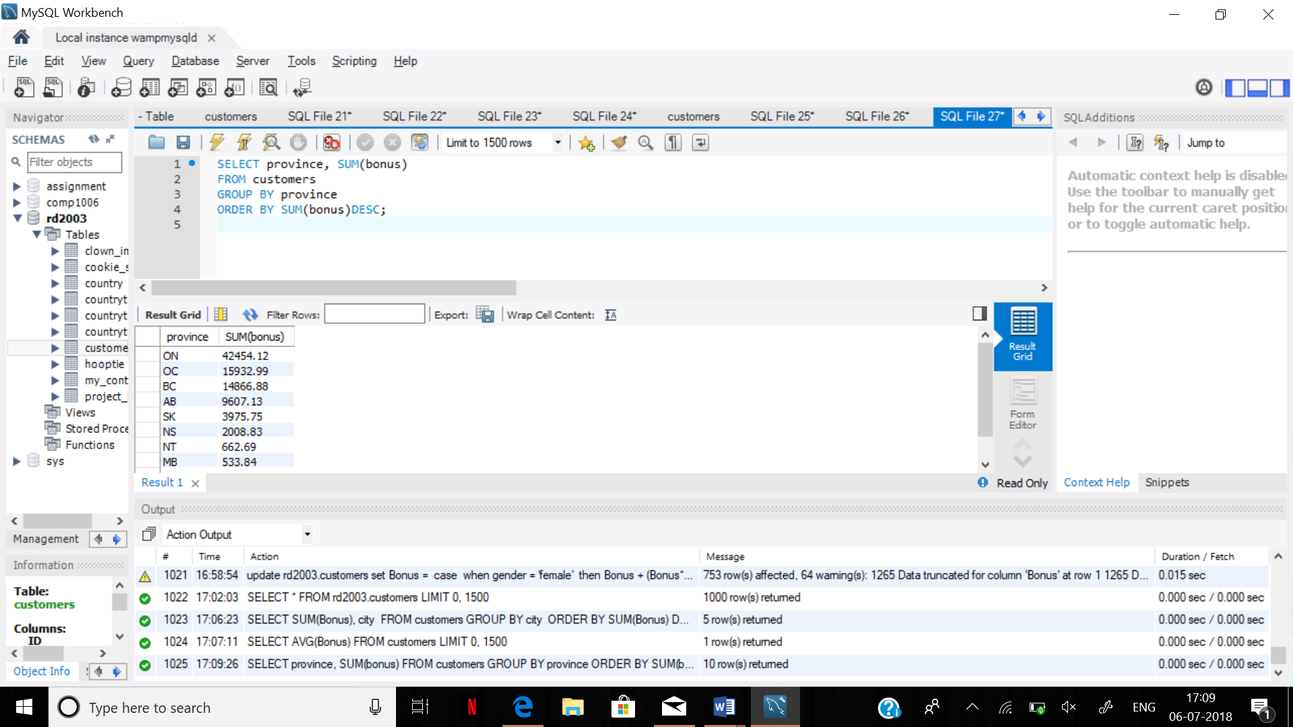

SELECT province, SUM(bonus)

FROM customers

GROUP BY province

ORDER BY SUM(bonus)DESC;

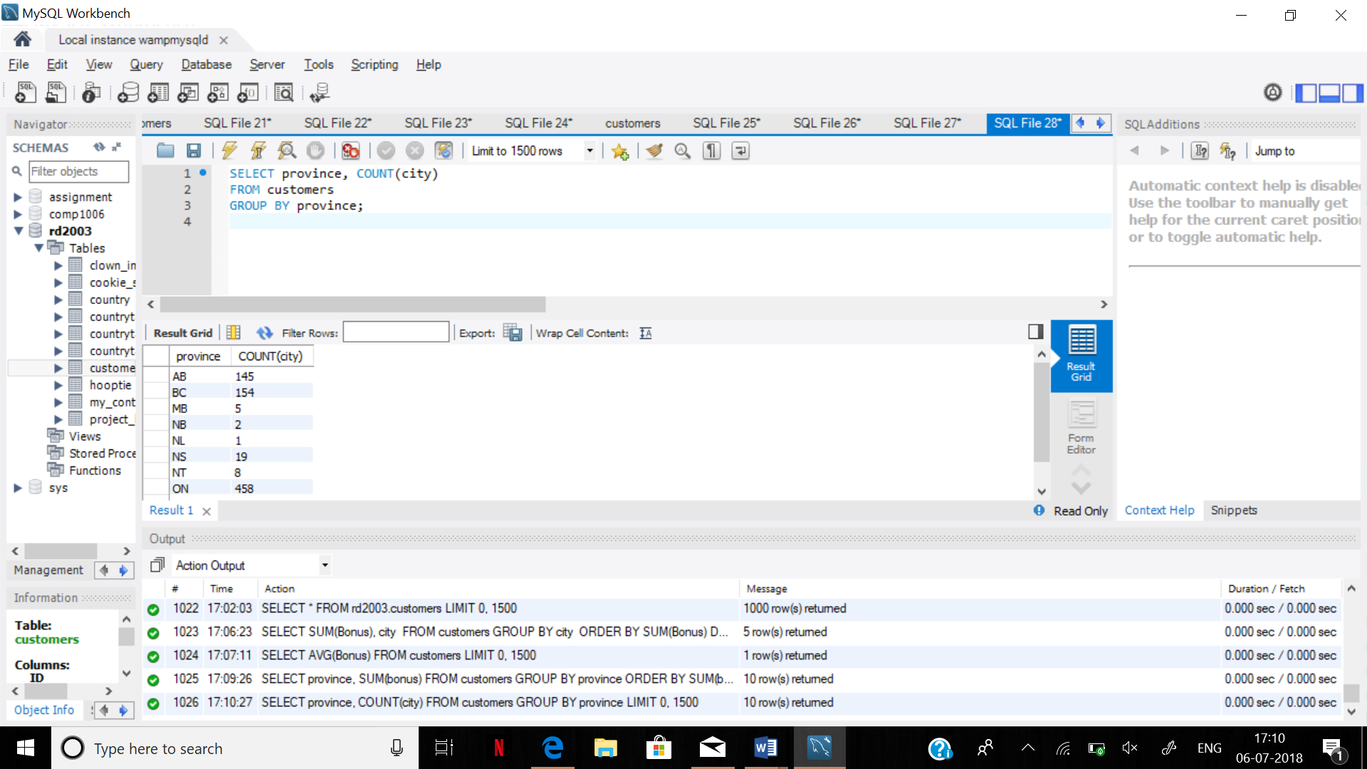

SELECT province, COUNT(city)

FROM customers

GROUP BY province;

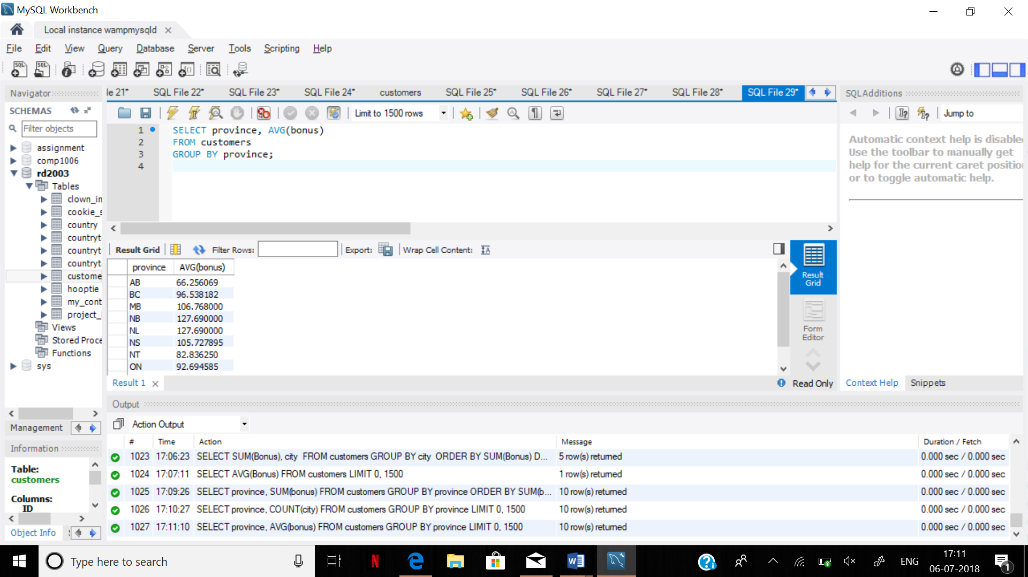

SELECT province, AVG(bonus)

FROM customers

GROUP BY province;

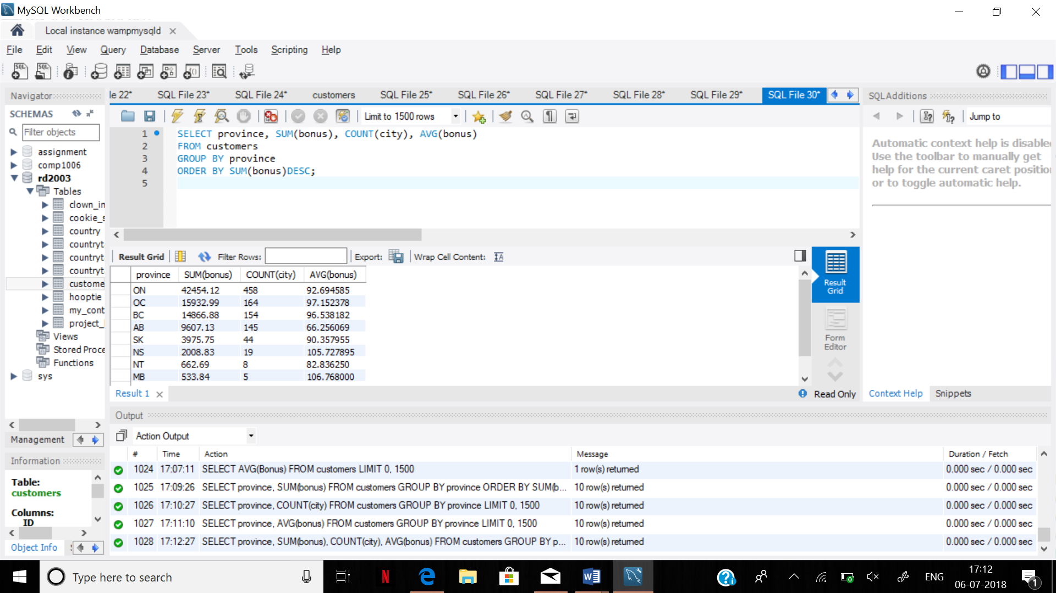

SELECT province, SUM(bonus), COUNT(city), AVG(bonus)

FROM customers

GROUP BY province

ORDER BY SUM(bonus)DESC;

6.5

Ans. It is showing how many people live in a particular city.

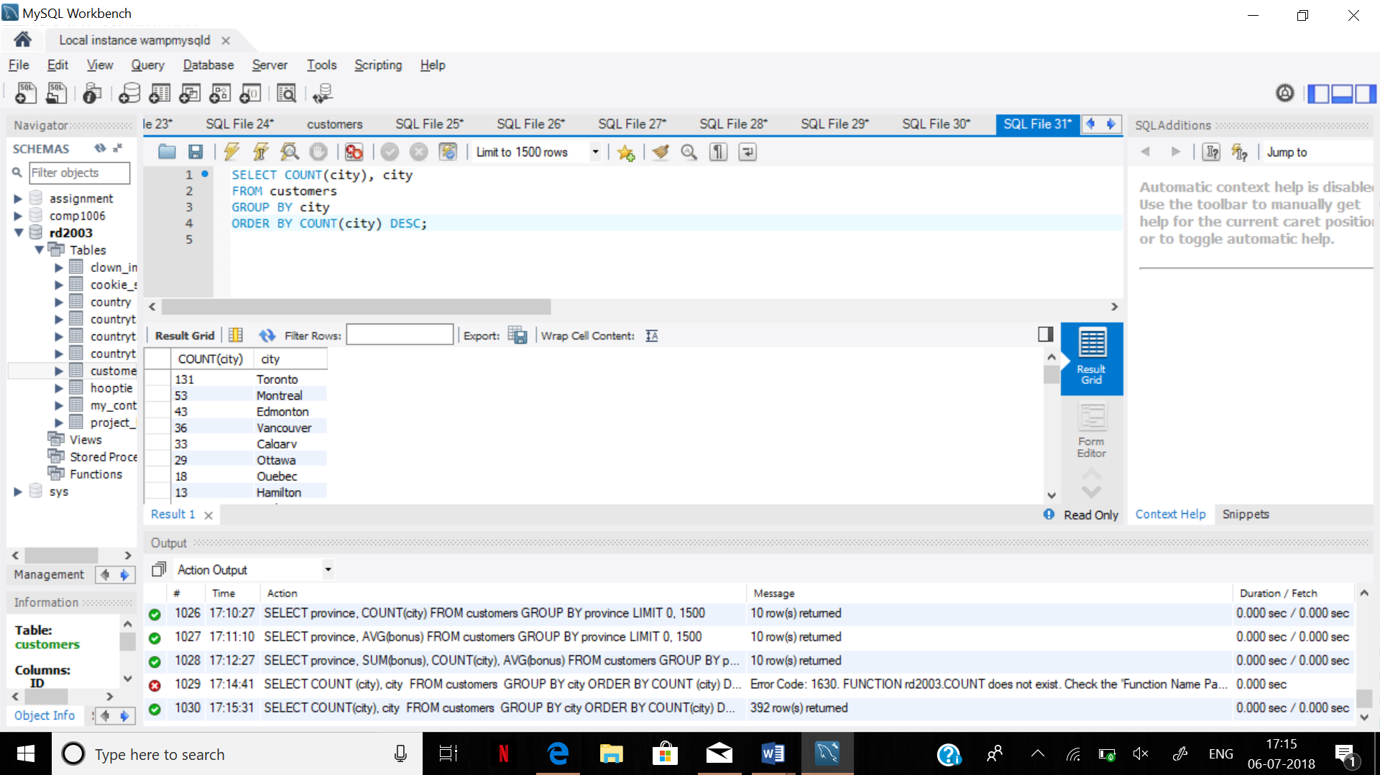

**Step 7:**

* Our customers are buying books. We need to keep the names of the books and the customers who bought them in another table.
* Create a second table. Name it ‘Sale’.
* The columns are: BID, Book_Name, Customer_ID, Purchase_Date.
* Relate two tables with customer_ID as the foreign key.

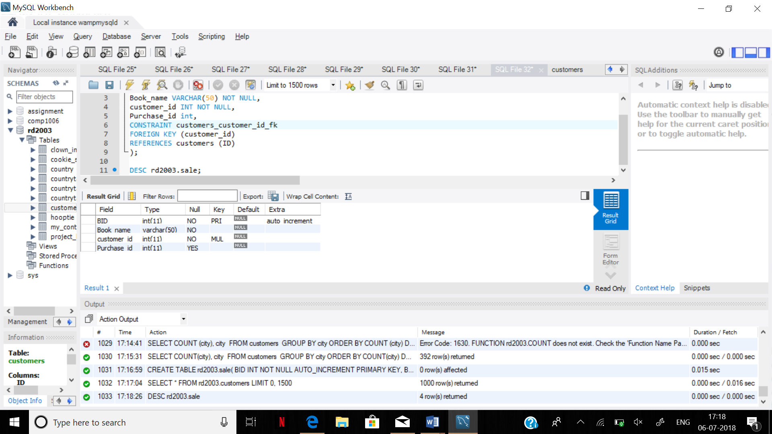

CREATE TABLE rd2003.sale(

BID INT NOT NULL AUTO_INCREMENT PRIMARY KEY,

Book_name VARCHAR(50) NOT NULL,

customer_id INT NOT NULL,

Purchase_id int,

CONSTRAINT customers_customer_id_fk

FOREIGN KEY (customer_id)

REFERENCES customers (ID)

);

Step 8.

